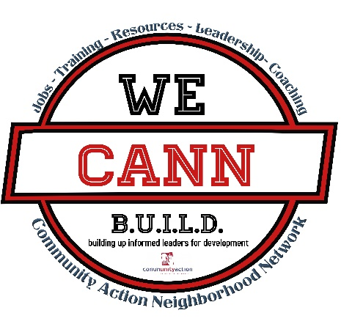

Community Action of Greater Indianapolis

WE CANN B.U.I.L.D Trauma & Resilience Learning Collaborative

Application

ORGANIZATION
- Describe your organization, services, and population served.

- What is the value for your organization participating CAGI WE CANN Trauma & Resilience Learning Collaborative project? Briefly describe your initial ideas about how it might impact your long- and short-term goals.

- What has your organization achieved or worked toward regarding trauma-informed practices or frameworks on an organizational level?

- Approximately how members of your team (staff, volunteers, clients/families) have attended a trauma training? (And where did they receive that training – include if known)

- Do you have any funding or requirements on about trauma, ACES, or trauma informed care that you will need to meet?

- Have you been working on implementing trauma-informed practices or frameworks on an organizational level? Have you had any success? If yes, please briefly share?

- How has your organization been impacted by Covid -19/ Coronavirus?

INDIVIDUAL (for the primary liaison to complete)
- What is your personal experience engaging in trauma-informed practices or frameworks?

- What do you see as the personal value you will gain through participating in this process?

- What potential barriers may you face engaging in the learning collaborative, and how would you address these barriers?

- After review of the background information for the learning collaborative structure and projects, what reactions or recommendations do you have? Response optional.

PARTICIPATION IN THE LEARNING COLLABORATIVE
The WE CANN Learning Collaborative process will take place from May – December 2021 and will require your participation in completing a trauma informed care organizational assessment and developing an implementation plan. What barriers do you envision in participating and completing this process with your staff, receiving feedback, and sharing with the rest of the other participant organizations in the learning collaborative and/or the larger community?

